Electricity Consumption & Energy Production Intelligence

Project Report — Data Analytics and Machine Learning

This project analyzes hourly electricity consumption and electricity generation by energy source, identifies temporal demand patterns, studies the production-consumption balance, and uses a Random Forest model for short-term demand forecasting.

Problem Statement
Electricity systems must understand demand patterns and generation composition to support planning and efficient resource allocation. This project converts hourly electricity records into KPIs, trends, energy-mix insights, energy-balance analysis, and a short-term demand forecast.

Objectives
  - Clean and validate the hourly electricity dataset.
  - Analyze electricity consumption across time.
  - Analyze production by energy source.
  - Compare renewable and non-renewable generation.
  - Study production versus consumption.
  - Forecast future electricity consumption using a simple machine-learning model.
  - Present results through an interactive Streamlit dashboard.

Dataset
Dataset: Hourly Electricity Consumption & Production (Kaggle). Source: https://www.kaggle.com/datasets/mayuringle8890/electricity
Field | Purpose
DateTime | Hourly timestamp
Consumption | Total electricity consumed during the hour (MWh)
Production | Reported total electricity production (MWh)
Nuclear | Nuclear generation
Wind | Wind generation
Hydroelectric | Hydroelectric generation
Oil and Gas | Oil and gas generation
Coal | Coal generation
Solar | Solar generation
Biomass | Biomass generation

Data Cleaning & Preparation
The raw file contains 46,011 records and 10 columns. There are 0 missing cells. Four exact duplicate rows were removed. Repeated timestamps were aggregated using the mean of numerical observations. Time features (hour, day of week, month, year) were created. The reported Production column was retained as the authoritative total. Negative Wind observations were clipped only for renewable-source calculations. The raw Wind field was not overwritten.

Exploratory Data Analysis
The highest recorded consumption is 9,615 MWh at 2021-01-19 10:00:00. The lowest is 3,889 MWh at
2023-06-04 06:00:00. Average demand is highest around 20:00 and lowest around 03:00. Average weekday consumption is 6,810 MWh compared with 6,033 MWh on weekends.

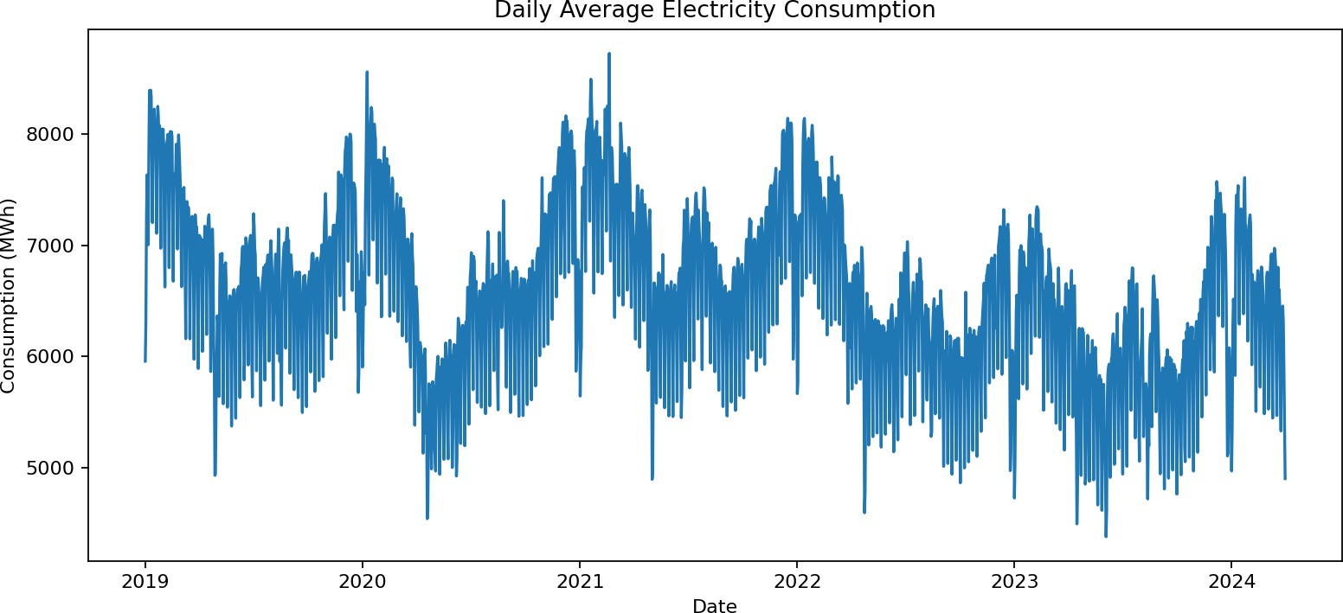

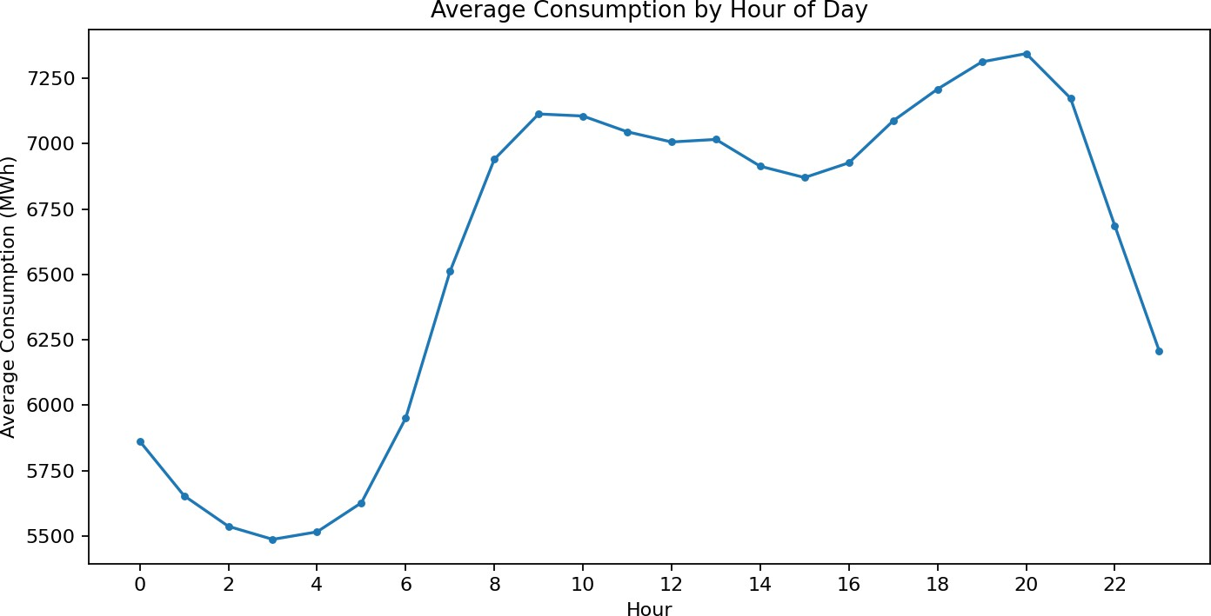

Energy Production & Energy Mix
The production section compares nuclear, wind, hydroelectric, oil and gas, coal, solar, and biomass generation. Renewable generation is defined for this project as Wind + Hydroelectric + Solar + Biomass. Non-renewable generation is defined as Nuclear + Oil and Gas + Coal.
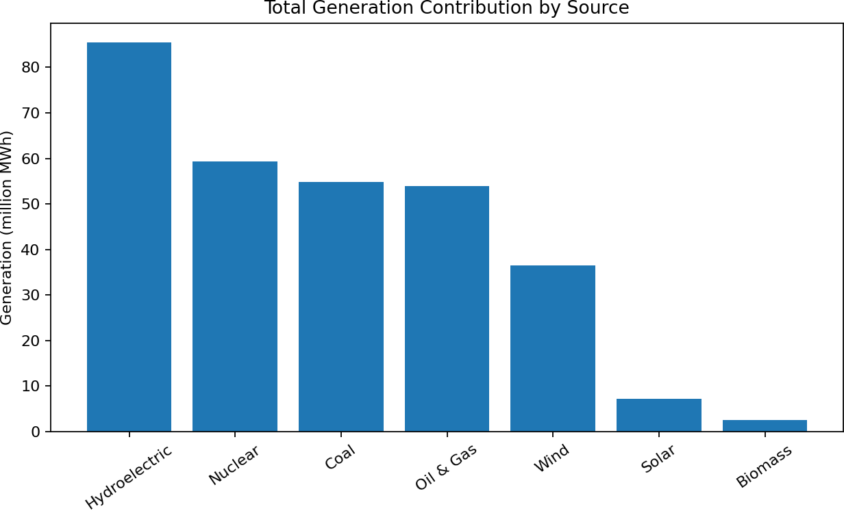

Across the recorded source-level generation totals, the renewable share under this definition is approximately 43.9%. Hydroelectric generation is the largest individual source in the dataset, followed by nuclear generation.

Consumption vs Production
Energy balance is calculated as Production − Consumption. A positive value represents production above reported consumption for that hour, while a negative value represents consumption above reported production. Across the cleaned records, approximately 43.5% have positive balance and 56.4% have negative balance. This is a descriptive measure and is not interpreted as a complete grid-import/export measure because the dataset does not contain all grid-flow variables.

Machine Learning — Demand Forecasting
The target variable is Consumption. The model uses hour, day of week, month, day of year, 1-hour lag, 24-hour lag, 168-hour lag, and 24/168-hour rolling averages. A chronological 80/20 train-test split is used to avoid training on future observations.
Model | Random Forest Regressor
Train/Test split | 80% / 20% chronological
MAE | 95.54 MWh
RMSE | 128.46 MWh
R² | 0.981

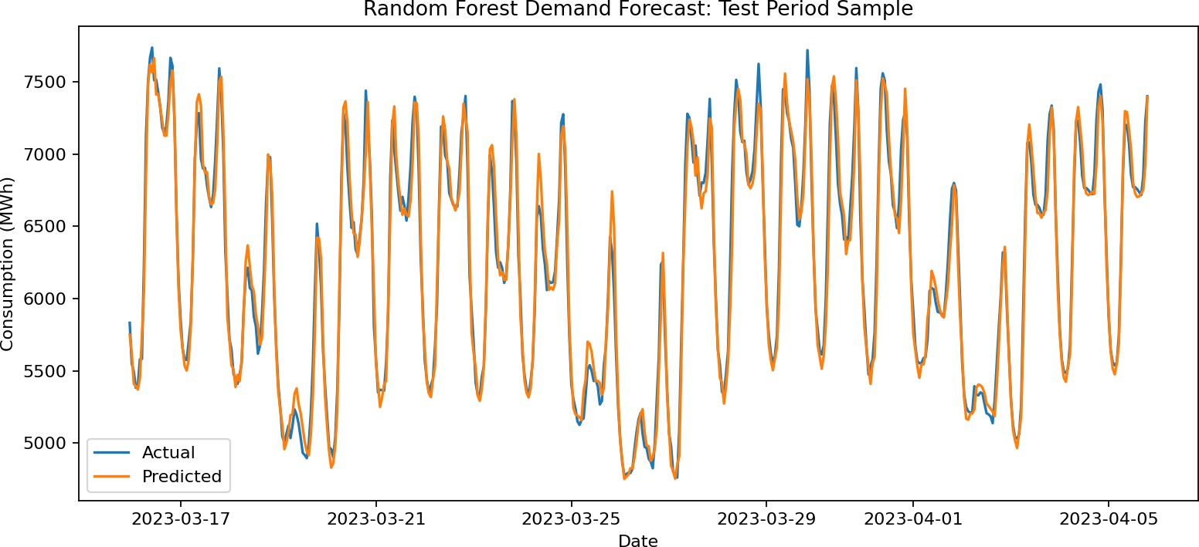

Dashboard Design
The Streamlit dashboard is organized into five sections: Executive Overview, Consumption Analysis, Energy Production, Demand Forecast, and Insights & Data Quality. The design emphasizes KPIs, trends, drivers/patterns, risks/opportunities, and actions rather than maximizing the number of charts.

Key Insights & Recommended Actions
  - Peak demand occurs around the 20:00 hour on average; energy planning can pay particular attention to recurring high-demand periods.
  - Weekend average consumption (6,033 MWh) is lower than weekday average consumption (6,810 MWh), indicating a strong calendar effect.
  - Hydroelectric, nuclear, coal, and oil/gas are the largest source categories in the supplied source-level data; the energy mix can therefore be monitored over time rather than using a single-generation KPI.
  - Negative Wind observations are treated as a data-quality issue for source-mix calculations rather than being presented as physical negative generation.
  - Production and consumption should be viewed together: periods with a negative reported balance deserve attention in demand/generation planning, while positive periods indicate comparatively higher reported production.
  - The forecasting model provides a decision-support estimate of near-term demand. It should be retrained as new data becomes available and should not be interpreted as a guarantee of future demand.

Limitations
  - No temperature, weather, population, price, or industrial-activity variables are included.
  - The dataset has some negative Wind observations and inconsistencies between the reported Production total and source-level sums.
  - The forecast is based on historical temporal patterns and lagged demand only.
  - The dataset does not identify geographic/state-level consumption in the supplied file.

Future Scope
  - Integrate weather and temperature data.
  - Add regional/state-level electricity data.
  - Add anomaly detection for unusual demand or generation patterns.
  - Compare additional forecasting algorithms.
  - Connect the dashboard to a live or regularly updated electricity data source.

Conclusion
The project converts hourly electricity records into an interactive decision-support system. It combines descriptive analytics, energy-source analysis, production-consumption balance, and a simple forecasting model. The result is designed to support understanding of demand patterns and short-term planning while keeping the methodology explainable for an academic viva.

